**RESUME**

**Complete Name – Neha Kandari**

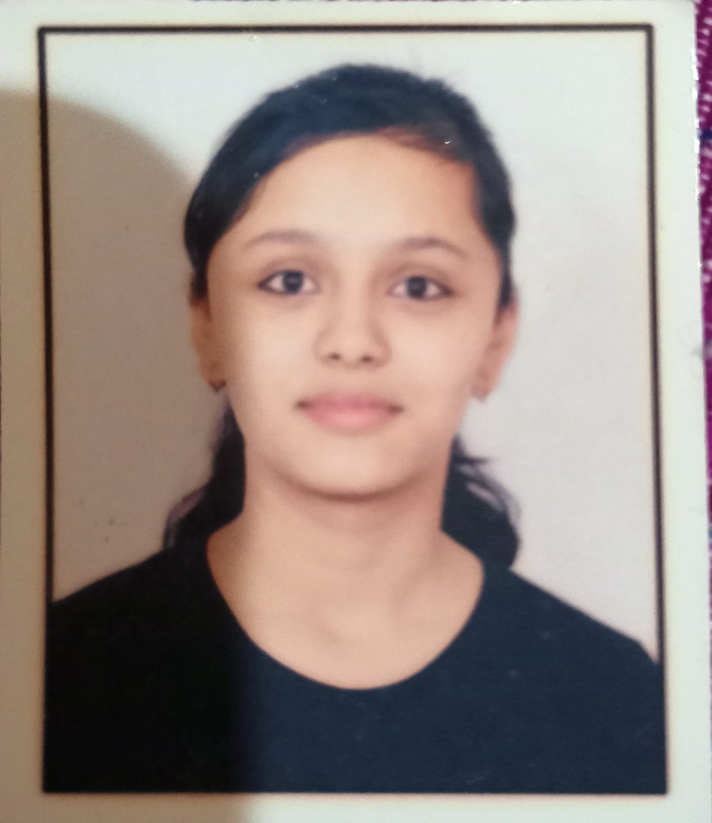 HOTO

Address: F-81 Dharam colony Palam vihar extension

Email ID - nehakandari64@gmail.com

Contact No. 9311614474

LinkedIn Profile link: www.linkedin.com/in/neha-kandari-046206235

**CAREER OBJECTIVE:**

Seeking a position in the field of Computer Science where I can utilize my skills to further work towards personal and professional development and contribute towards the prosperity of the organization.

ACADEMIC BACKGROUND:

Pursuing B. Tech in COMPUTER SCIENCE ENGINEERING & TECHNOLOGY from dronacharya College of Engineering, Gurgaon, Approved by AICTE.

|  |  |  |  |
| --- | --- | --- | --- |
| Institute/University | Degree/Examination | Percentage | Year |
| Dronacharya college of engineering | B. Tech | Pursuing (1st year) | 2021-22 |
| SCR Public School | 12th | 90.8% | 2021 |
| SCR Public School | 10th | 93.8% | 2019 |

**TECHNICAL SKILLS:**

* Language:  Basic concepts of C
* Operating Systems:  Windows10

# WORKSHOPS AND TECHNICAL EVENTS:

* Attended two days Web Development Workshop at Dronacharya College of Engineering in December 2021.

**STRENGTHS:**

* The ability to Work in a team.
* Hard-working with lots of patience.
* Self-motivated.
* Honest toward my work.
* Open-minded.
* Punctual

**EXTRACURRICULAR ACTIVITIES:**

* Likes to play badminton and indoor games.
* Listening music